SOLUTION ARCHITECTURE

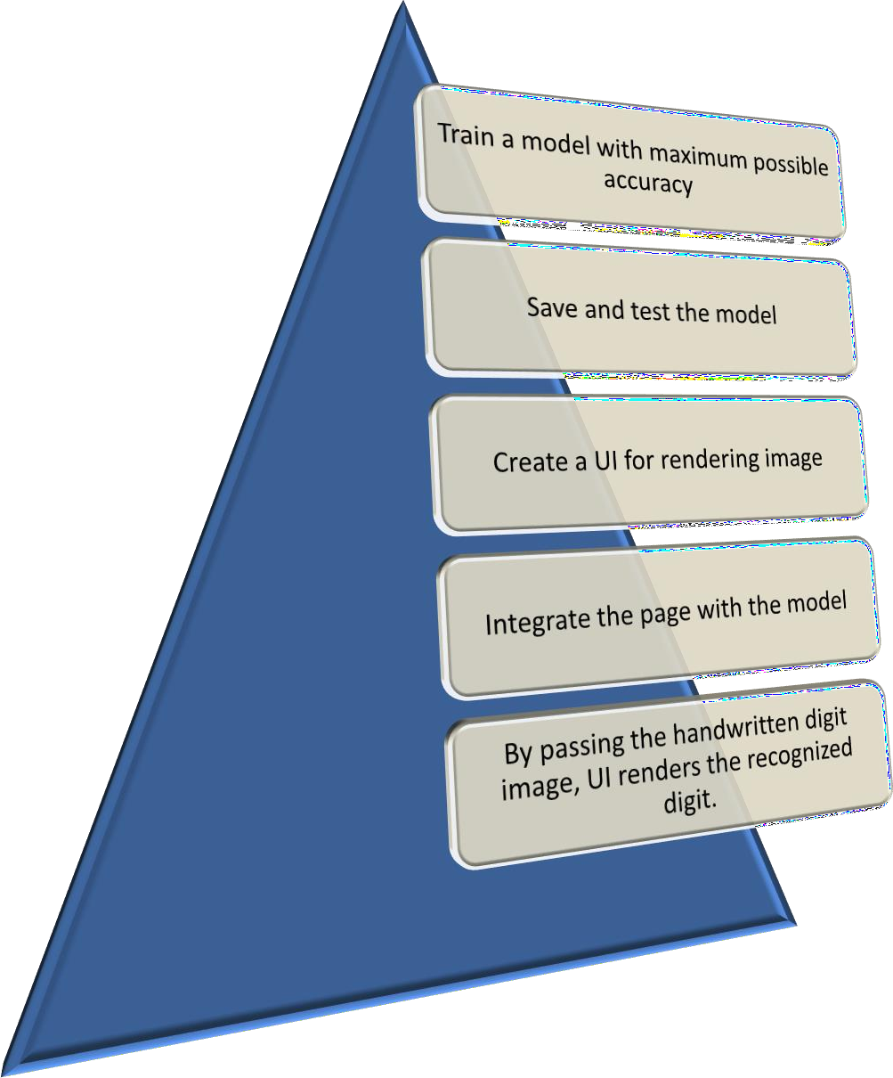

|  |  |
| --- | --- |
| Team ID | PNT2022TMID51438 |
| Project Name | A Novel Method for Handwritten  Digit Recognition System |
| Team Members | AdlinAjay, ,Ashwin , Bharath , Devarichardsan |